Question 1)



Question 2)

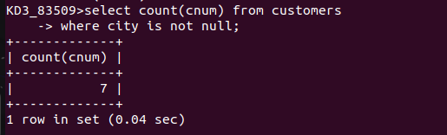

Question 3)

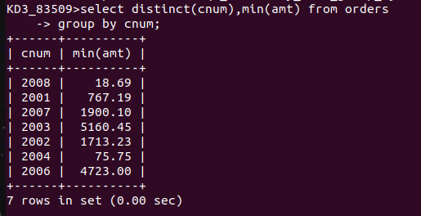

Question 4)



Question 5)

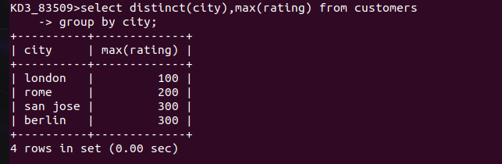

Question 6)

